# INDRODUCTION :

# overview

## I Design a social media post using in this canva .

## That was very easy to use . Anyone to use this canva easier.

# Purpose

## My project is creating a social media post.

## I Create a social media post using in this canva.

# 2. Problems Definition&Design Thinking

## 2.1 Empathy map

# 2.2 Brain strom and idea prioritization

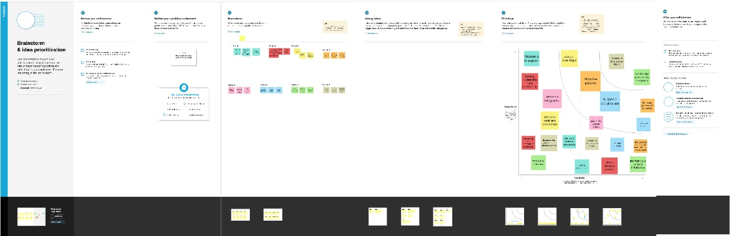

# 3. Result

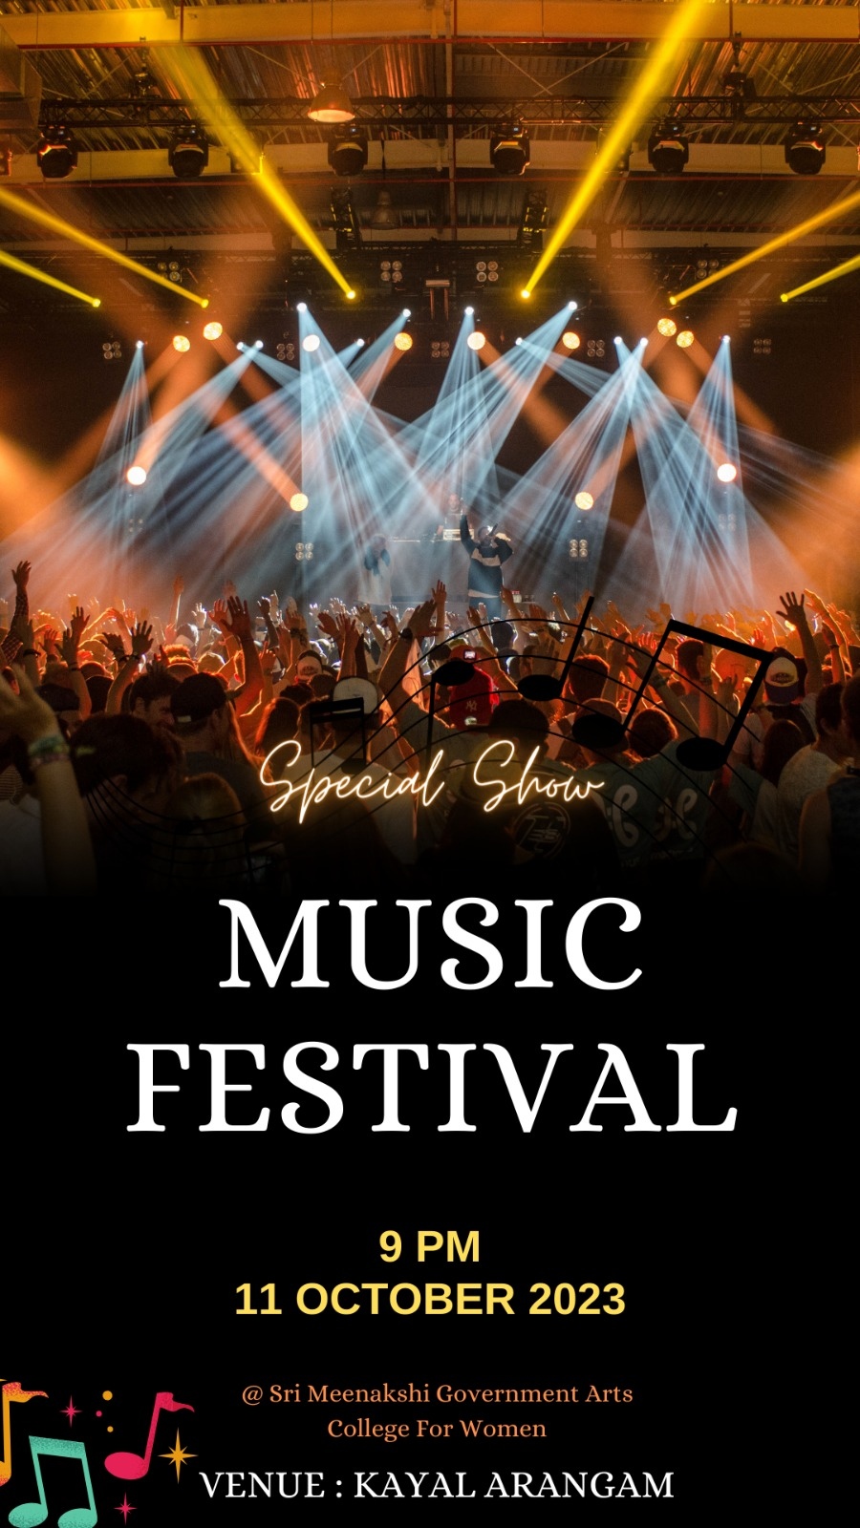

## 4 ADVANDAGES AND DISADVANDAGES

## Easy to using this canva

## Freshers can easy to design anything inthis canva

## In this canva has many templates

## Canva was very useful to everyone

# 5. CONCLUSION

## I easily finish my project social media post. canva is the most useful and best app for the freshers . Beacause , that has has many templates that was easy to use .